Project Design Phase-2

Data Flow Diagram & User Stories

|  |  |
| --- | --- |
| Date | 28 October 2022 |
| Team ID | PNT2022TMID40963 |
| Project Name | IOT Based Small Crop Protection System  For Agriculture |
| Maximum Marks | 4 Marks |

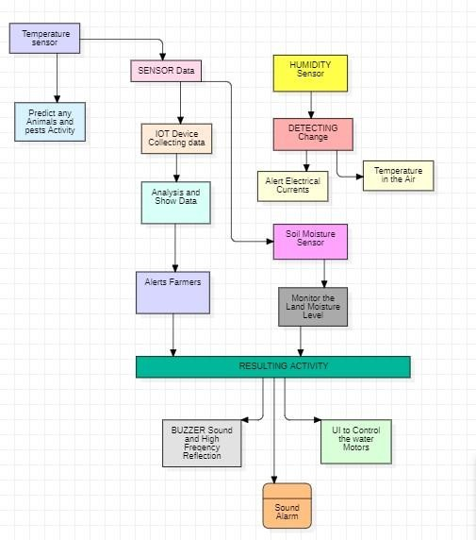

|  |  |  |  |  |  |  |
| --- | --- | --- | --- | --- | --- | --- |
| User Type | Functional requiremen t (Epic) | User Story number | User Story/Task | Acceptance criteria | Priority | Release |
| Customer (Mobile  user) | Registratio n | USN-1 | User can enter into the web application | I can access my account  /dashboard | High | Sprint 1 |
|  |  | USN-2 | User can register their credentials like email id and password | I can receive confirmation email &click  confirm | High | Sprint 1 |
|  | Login | USN-3 | User can log into the application y entering  email and password | I can login to my account | High | Sprint 1 |
|  | Dashboard | USN-4 | User can View the temperature | I can view the data given by the  device | High | Sprint 2 |
|  |  | USN-5 | User can view the level of sensor monitoring value | I can view the data given by the device | High | Sprint 2 |
| Customer (Web user) | Usage | USN-1 | User can view the web page and get the informaton | I can view the data given by the device | High | Sprint 3 |
| customer | Working | USN-1 | User act according to the alert given by the device | I can get the data work according to it | High | Sprint 3 |
|  |  | USN-2 | User turns ON the water motors/Buzzer/Sound Alarm when occur the disturbance on field | I can get the data work according to it |  | Sprint 4 |

|  |  |  |  |  |  |  |
| --- | --- | --- | --- | --- | --- | --- |
| Customer care Executive | Action | USN-1 | User solve the problem when some faces any usage issues | I Can solve the issues when some one fails to understandin g the procedure | High | Sprint 4 |
| Administrati on | Administrat ion | USN-1 | Use store every information | I Can store the gained information | High | Sprint 4 |